Chapter 2, exercise 1

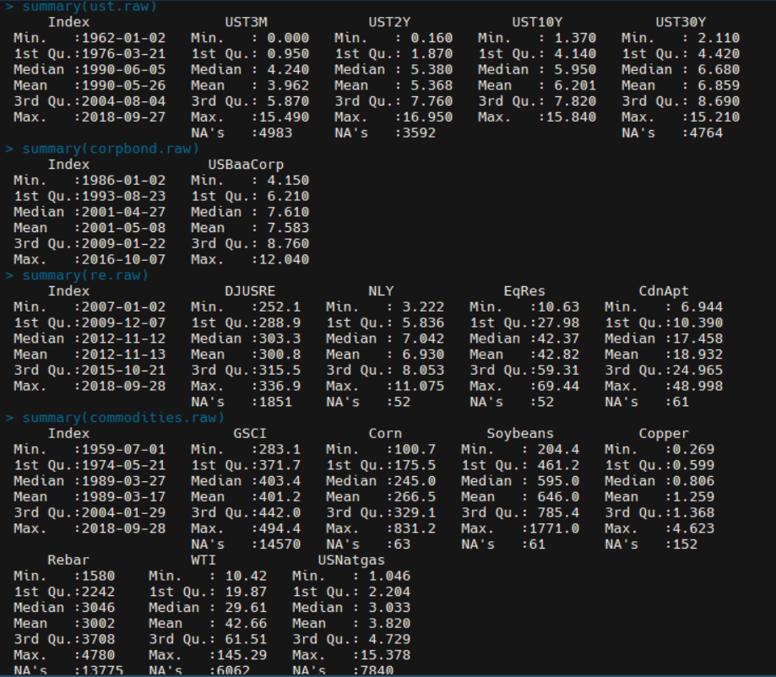

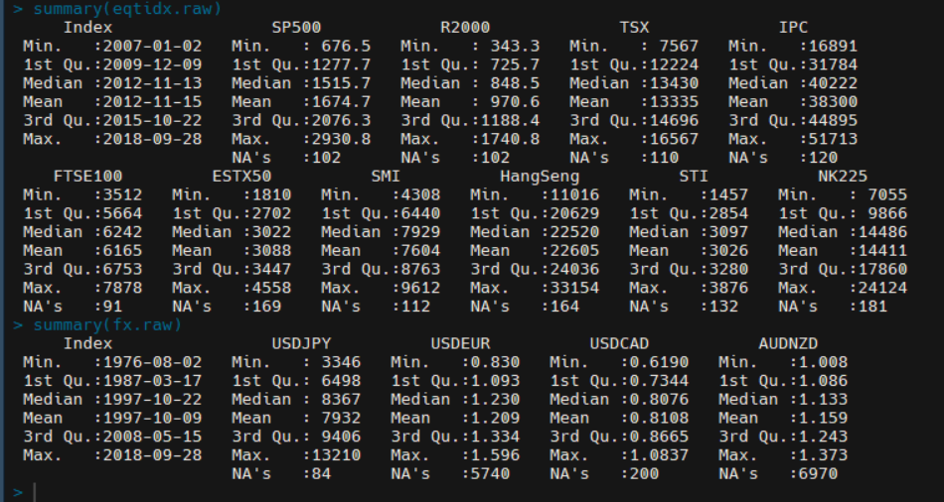

There are several different asset classes or “groupings” in this analysis: (note: plots were not used for this commentary; only summaries were used to generate this commentary)

1. Fixed-Income (US-Treasury Rates (3-month, 2-year, 10-year, and 30-year) and Moody’s Yield on Seasoned US-Corporate Bonds (BAA))
   1. Using the summary function alone, these fixed-income instruments would appear to be relatively stable, as the InterQuartile Range is fairly narrow and the distance between (1Q, Mean) and (3Q, Mean) is roughly the same size. There are outliers, however, as can be seen in the Max. for these instruments (between 12.04 and 16.95).
2. Real Estate (Real Estate Indices (US/Canada) and RE investment/trust firms)
   1. Similar to the fixed income asset class, Real Estate tends to stay in a narrow interquartile range and is balanced pretty evenly around the mean for each instrument. There are very nasty outliers however; for example: the Canadian Apartments REIT has an interquartile range ~14.6 (1Q at 10.39 and 3Q at 24.97), with a mean of 18.95. The max, however, is a whopping 48.99, which is nearly 2.5x the average price!
3. Commodities
   1. In contrast to the previous two asset classes, commodities aren’t very stable at all. These instruments have a wide interquartile range relative to their mean, and the distance between their min/max and mean is much larger still! As a result, I’ve concluded that these instruments have wild and dramatic price movements.
4. Global Equity Indices
   1. Somewhat similar to commodities, these instruments tend to vary wildly; the IQR of these instruments tends to be wide and left or right-leaning when compared to the mean.
5. Foreign-Exchange
   1. The summary data of the FX asset class had some very interesting results. Using the same analysis methodology as before, I would have easily concluded that FX is a fairly stable asset class (aside from USDJPY, it would seem). The narrow IQR and equally-balanced mean (relative to 1Q and 3Q) are what initially led me to this conclusion. However, after generating the plots (more on that in exercise-2), I was very surprised to find that these instruments move around quite often, much more than I had originally thought.

Chapter 2, exercise 2

There are several different asset classes or “groupings” in this analysis:

1. Fixed Income
   1. The short-term (3M and 2Y) tend to mimic each other, and the long-term (10Y and 30Y) tend to mimic each other closely as well, but by no means would I call these “stable.” Since January’14, we’ve seen short-term rates rise from essentially zero (even slightly negative) to nearly 2% on the 3-month and over 2.5% on the 2-year.
   2. In addition, the 10 and 30-year rates have swung dramatically, falling 1.5-2.0% (respectively) to their lows midway through 2016. Rates have then dramatically risen through December 2017, with the 10-year returning to 3.0% and the 30-year rising to 3.0%, which is still almost a full percentage point lower than what it was at the beginning of 2014.
2. Foreign-Exchange
   1. These do not seem to follow much of a pattern at all. Each FX rate appears to follow a different path, but there are times when these paths have greater variance than what appears to be the “norm” for each rate. If there is any pattern that can be discerned, it may be that the FX for a given country does follow somewhat of a similar path (at least weakly) with FX rates of that country and other market participants; the USD-JPY/EUR/CAD plots are a good demonstration of this. While the trajectory of these rates are by no means identical, there is definitely a positive correlation here.
3. Real Estate
   1. These assets follow a similar path, but with varying degrees. EQR and NLY, both significantly involved in the US real estate market (Trust/Investment firms) appear to closely follow the DJUSRE Index (for obvious reasons).
   2. CdnApt (in Canada) resembles the DJUSRE but to a much lesser extent. It would appear that the downturns in the US Real Estate market have some degree of effect on the Canadian market, but the upswings in the Canadian RE market don’t have any affect on the US market.
4. Equities
   1. These instruments seem to follow a somewhat similar path, but this is not always in the case. They follow a similar path especially during global crises, such as the downswing in all markets caused by events such as Brexit and the 2016 US Presidential Election (mainly events in the latter part of 2016).
   2. Overall, it appears that these instruments follow a path in terms of regions. For example, the US and Canadian indices seem to follow each other in a much closer fashion than the US and Asian market indices follow each other. Similarly, the Asian market Indices seem to follow each other in a “group” and the Euro Indices seem to follow each other in a “group” as well, meaning that if there is a downturn in one large market in Europe, one might expect to see a downturn in the other Euro Indices as well, etc.
5. Commodities
   1. Commodity prices do not seem to follow a cohesive path either; each individual commodity follows a different path than other commodities. There are, however, very apparent spikes in prices at different times for each commodity. One good example of dramatic upswings/downswings in price is in Rebar, from early 2016 towards the end of 2017. Another example that shows a different, but dramatic swing in price is in Copper, which moved from lows of 2.0 in early-mid 2016 to 2.5 at the end of 2016, with another large upswing to 3.0 in the middle of 2017.
   2. Note there appears to be a data error in GSCI, as most of the plot is missing data (all of 2014, and the second half of 2015, 2016, and 2017 is missing)

Chapter 2, exercise 3

I would rather hold the index:

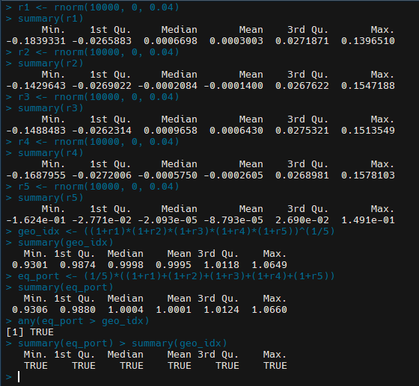

Chapter 2, exercise 4

Chapter 3, exercise 1

Chapter 3, exercise 2

Chapter 3, exercise 3

Chapter 3, exercise 4

Chapter 4, exercise 1

Chapter 4, exercise 2